Created by: David Rubio G.
Blog: https://soceame.wordpress.com/
GitHub: https://github.com/DRubioG
Last modification date: 11/03/25

To access the synthesis models you must first have the FW implementation done. Then you have to go to the Manage Constraints tab.
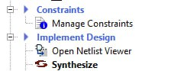
A tab will open for you to edit it.
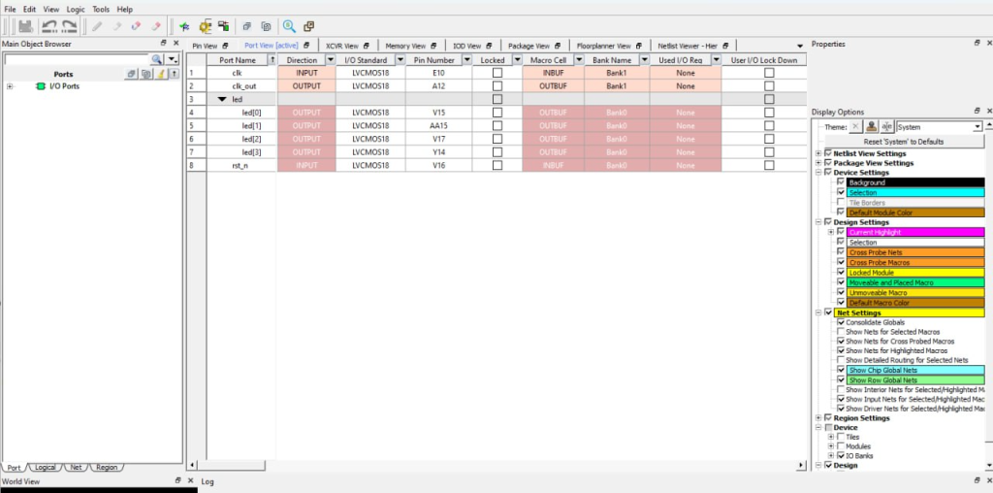
In the I/O Attributes tab you have to click Edit with I/O Editor.
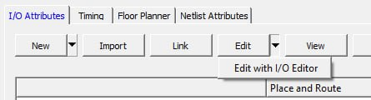
If you go to the Netlist Viewer – Hier tab a message like the following appears.

You just have to click on it and the synthesis model will open.
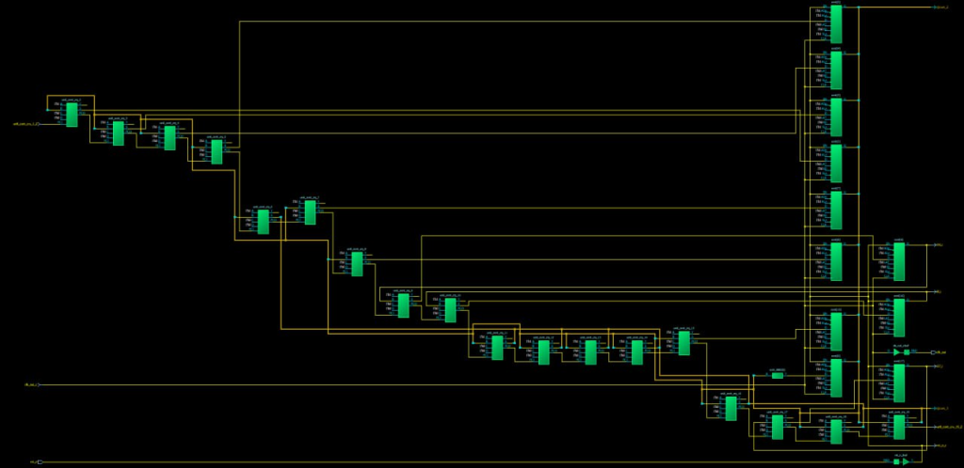
In the tab next to Netlist Viewer – Flat another message like this appears.

Just click on it as before.
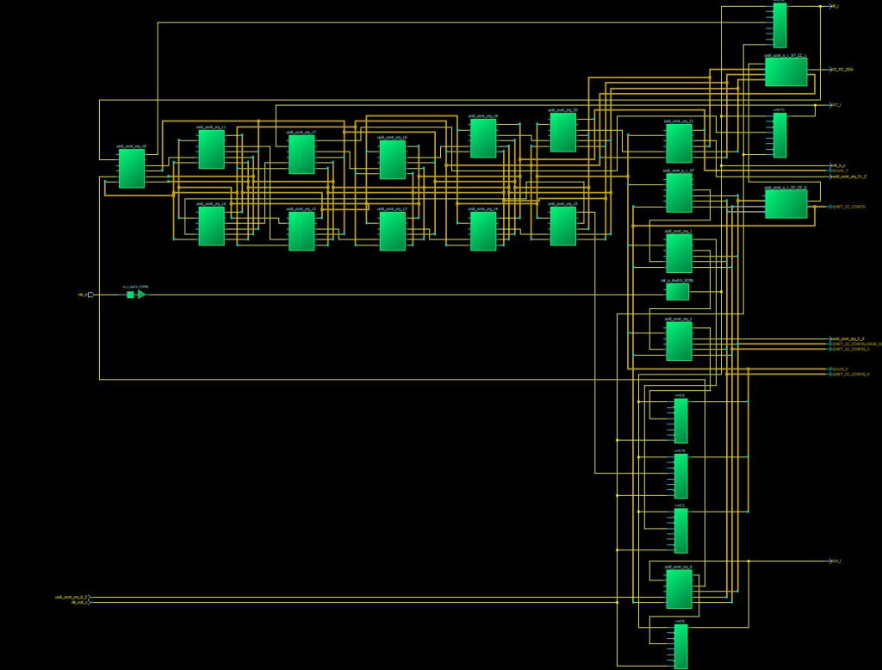
In the Floorplanner View tab you have the FPGA/SoC implementation model.
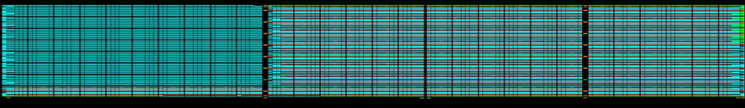
Finally in the Package View tab you have the model to configure the package pins.
